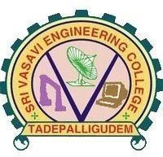

A COMMUNITY SERVICE PROJECT REPORT ON SOCIAL RESPONSIBILITY SURVEY

## Submitted in partial fulfillment for the award of the degree of

BACHELOR OF TECHNOLOGY

## IN

Computer Science and Engineering

## By

**VIPPARTHI VINITHA 22A81A05Q3**

## Under the Esteemed Supervision of MR.G. NATARAJ

**Assistant Professor**

**Department of computer science and Engineering (Accredited by N.B.A)**

SRI VASAVI ENGINEERING COLLEGE(Autonomous)

## (Affiliated to JNTUK, Kakinada)Pedatadepalli, Tadepalligudem-534101, AP

**2022-23**



# SRI VASAVI ENGINEERING COLLEGE

**(Autonomous)**

## Department of Computer Science and Engineering

**Pedatadepalli, Tadepalligudem**

This is to certify that the Community Service Project Report entitled “**MANAGEMENT OF FARMING**” survey done in ARDHAVARAM village, submitted by **VIPPARTHI VINITHA (22A81A05Q3)**, for the award of the degree of Bachelor of Technology in the Department of Computer Science and Engineering during the academic year 2022-2023.

Name of Project Guide Head of the Department

Mr.G.Nataraj Dr. D Jaya Kumari

Assistant professor Professor&HOD

**ACKNOWLEDGEMENT**

First and foremost, we sincerely salute to our esteemed institute **SRI VASAVI ENGINEERING COLLEGE**, for giving us this golden opportunity to fulfill our warm dream to become an engineer. Our sincere gratitude to our project guide **Mr.G.Nataraj, Assistant Professor**, Department of Computer Science and Engineering, for his timely cooperation and valuable suggestions while carrying out this project.

We express our sincere thanks and heart full gratitude to **Dr. D. Jaya Kumari, M.Tech, Ph.d, Professor & Head of the Department** of Computer Science and Engineering, for permitting us to do our project. We express our sincere thanks and heart full gratitude to **Dr. G.V.N.S.R. Ratnakara Rao, Principal**, for providing a favorable environment and supporting us during the development of this project.

Our special thanks to the management and all the teaching and non-teaching staff members, Department of Computer Science and Engineering, for their support and cooperation in various ways during our project work. It is our pleasure to acknowledge the help of all those respected individuals. We would like to express our gratitude to our parents, friends who helped to complete this

project.

VIPPARTHI VINITHA

(22A81A05N4)

# SRI VASAVI ENGINEERING COLLEGE

**(Autonomous)**

## Department of Computer Science and Engineering

**Pedatadepalli, Tadepalligudem**

## (2022-2023)

**Community Service Project for the UG Program Academic Performance Improvement**

**Name of the Student** : VIPPARTHI VINITHA

**Regd No** : 22A81A05Q3

**Branch** : CSE

Semester : III

**Topic** : Management of farming

**Area** : Pedatadepalli,Tadepalligudem

**Project Guide** : Mr.G.Nataraj Asst.Professor

(Student) (Project Guide)

Mr.G.Nataraj

Asst.Professor

**CONTENTS**

* Introduction
* Academic Performance Improvement Survey
* Awareness program & Photographs of Surveys
* Observation
* Suggestions
* Conclusion

# INTRODUCTION

Today to sustain in this competitive world one needs to have knowledge. the acquisition of knowledge is obvious in the field of education. But Education is not just a teacher’s lesson or an aspect that student reads in a book . It’s the perception of the content & surroundings by the student’s very own way. So the education need to be taught according to the student’s inclination towards it

.especially the students who are taking their part in the school with young nature have very un - catchy, non-judge able,correctable opinions regarding their career and their perception in terms of grasping the education.with regard to this Academic performance improvement survey isneeded.

So we’ve tried to spread our hands to the ends of student’s inner mind by surveying them regarding their academics as well as non-academics which also plays a per- dominant role in making one’s life cherish able.This survey covers all types of aspects like questioning, knowing their academic details and a chunk of feedback from the student’s side to know their heart regarding education. Academic performance can’t be improved by just counseling regarding how to perceive education, but also by giving proper requirements. And we took this survey in both private and public schools.

# PHOTOGRAPHS WITH SURVEYEES

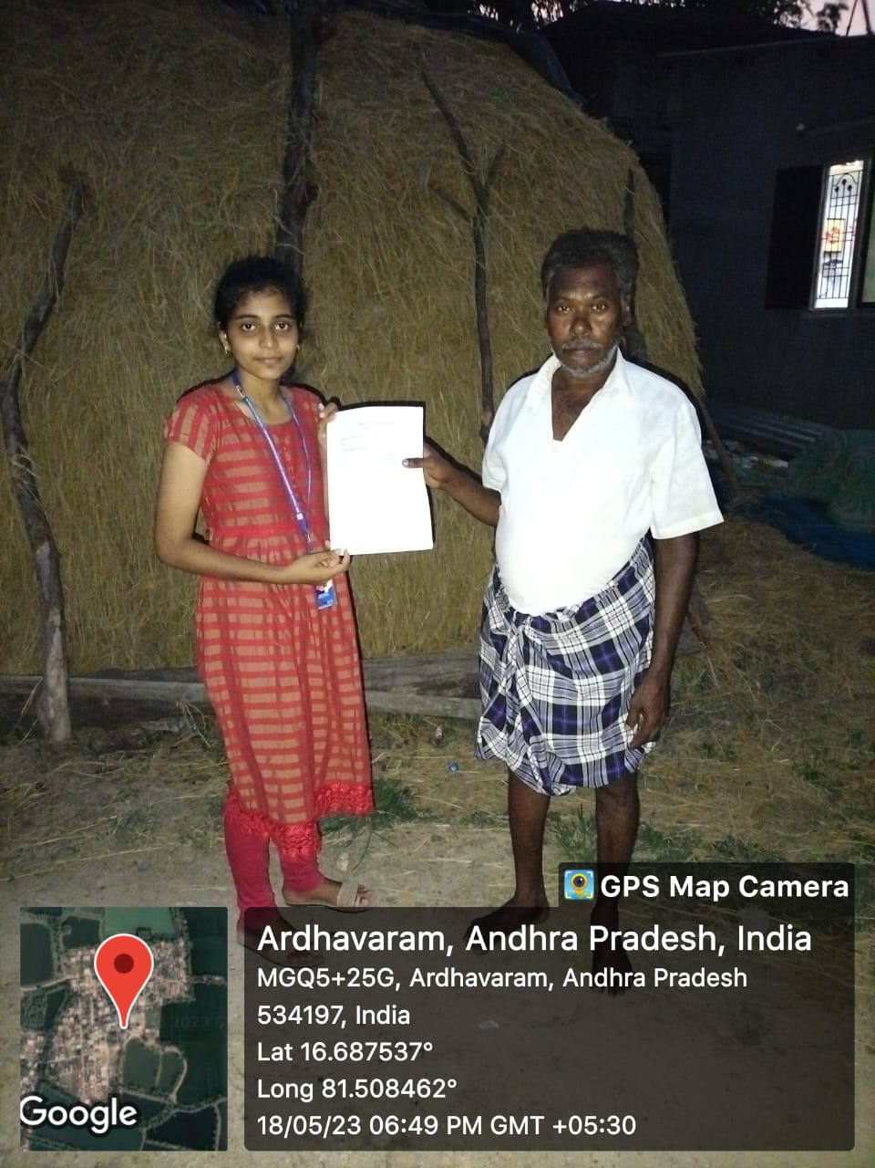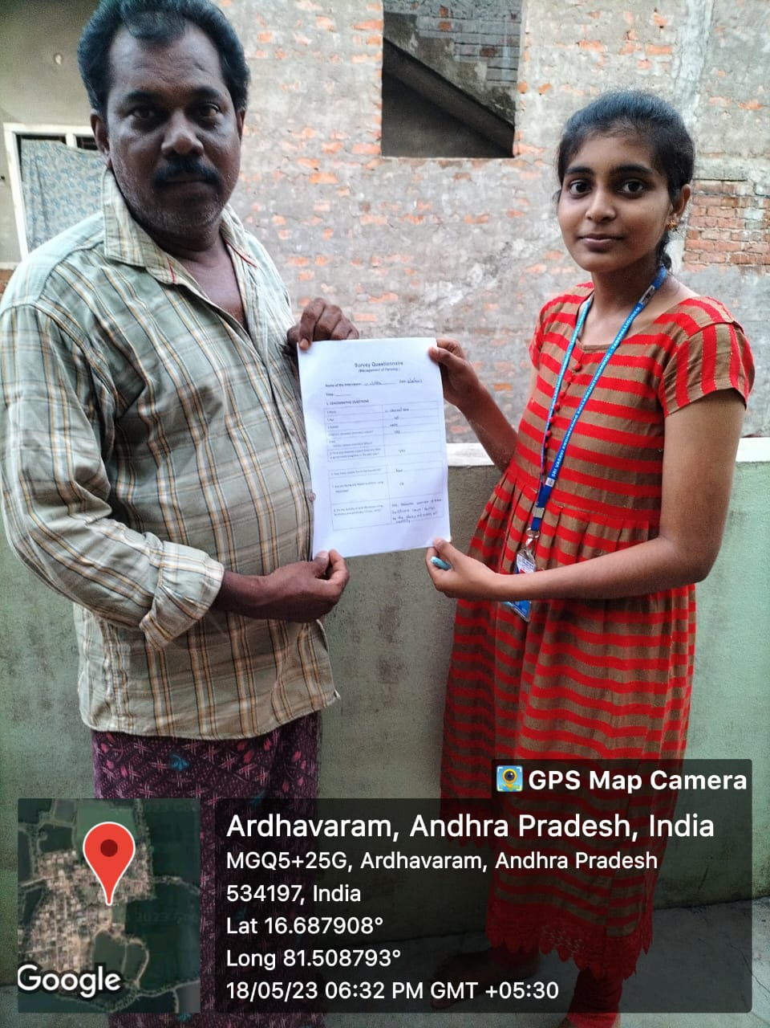

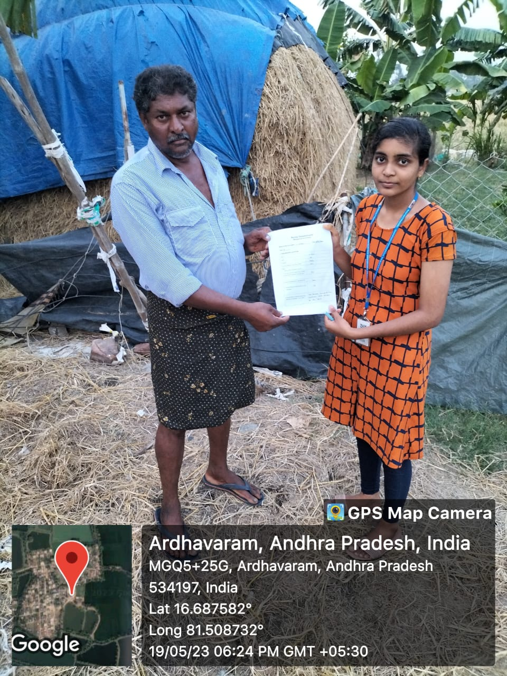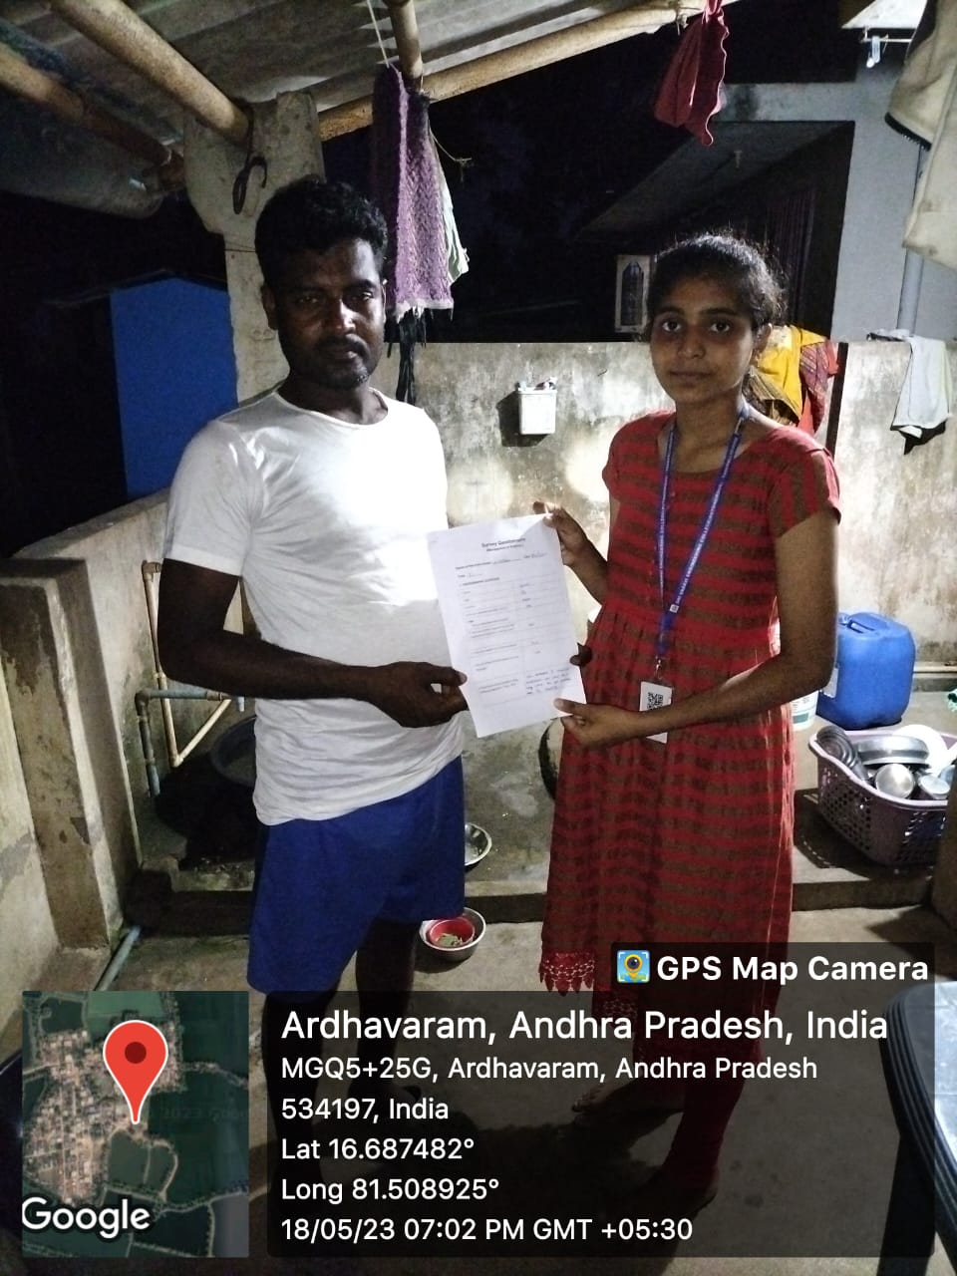

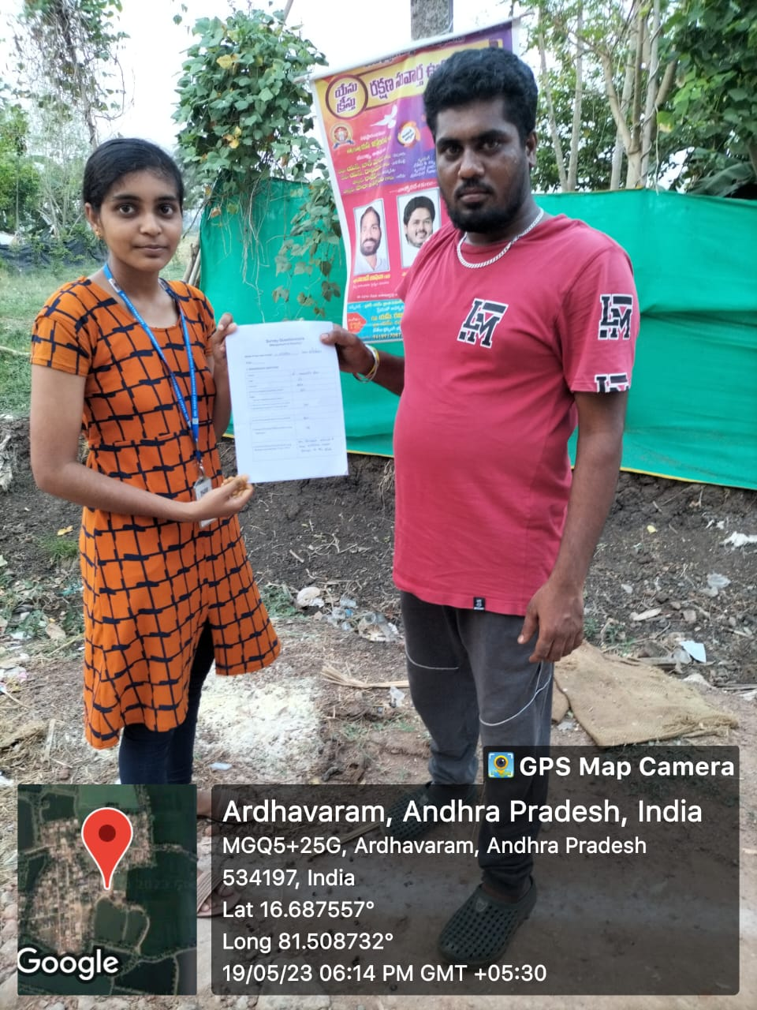

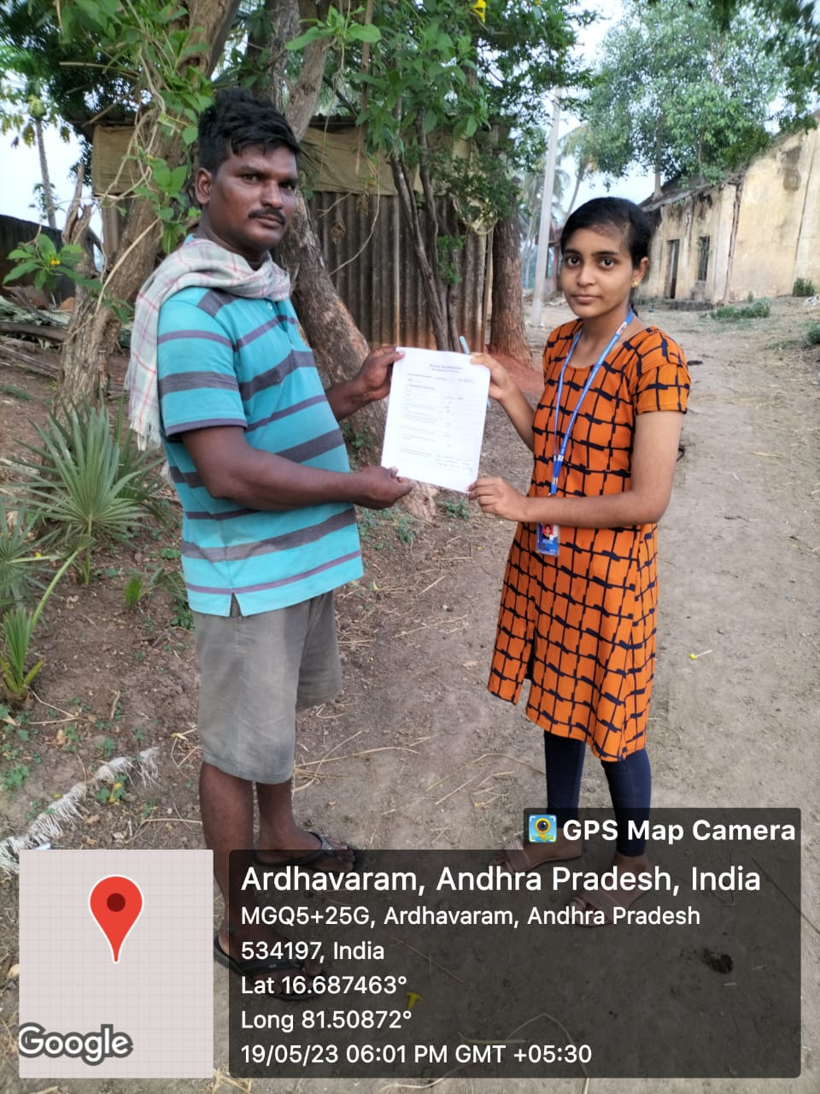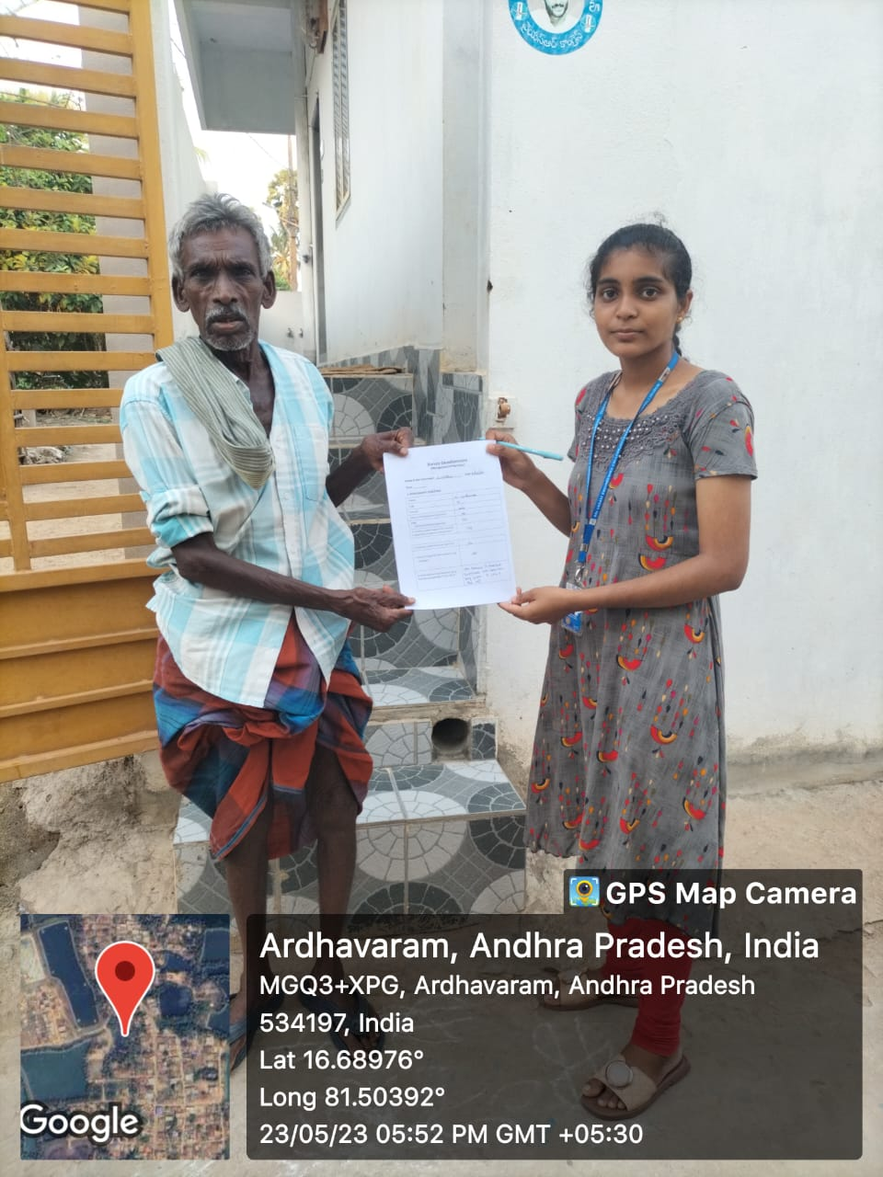

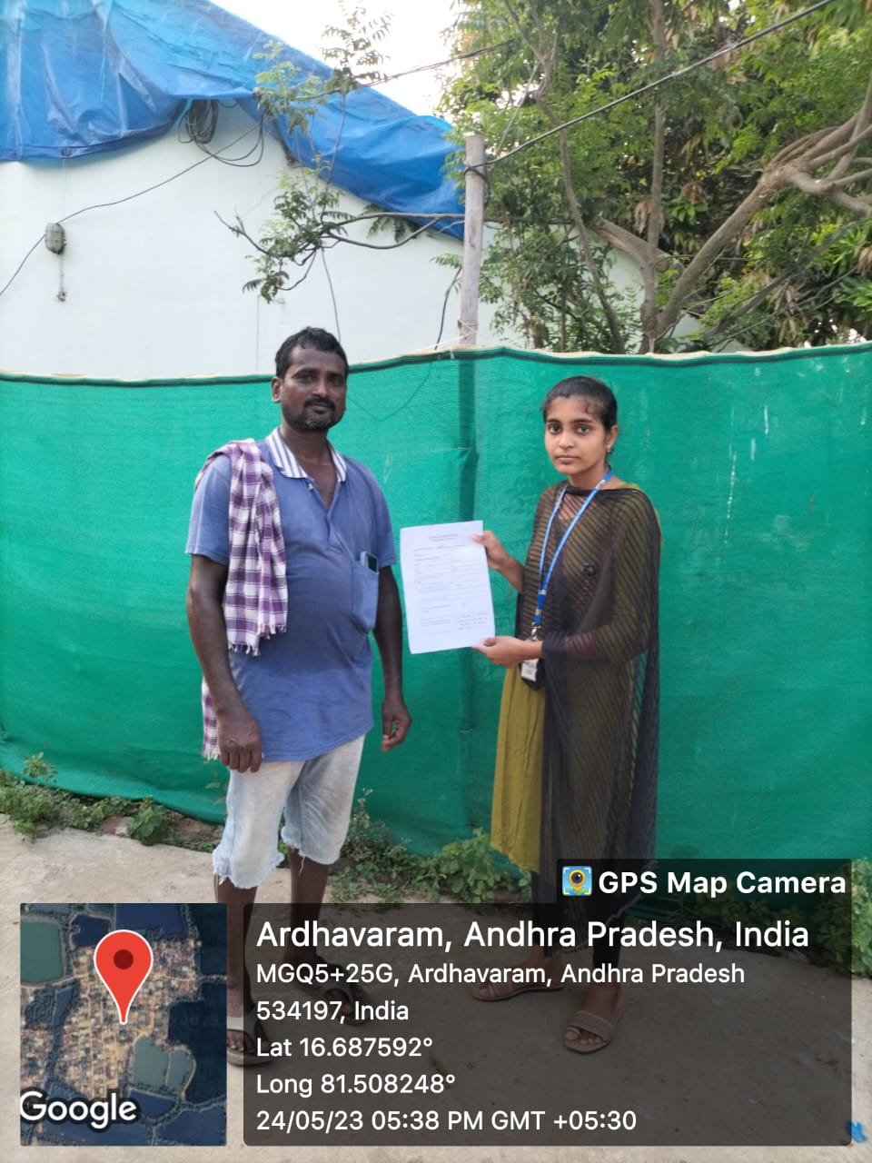**+**

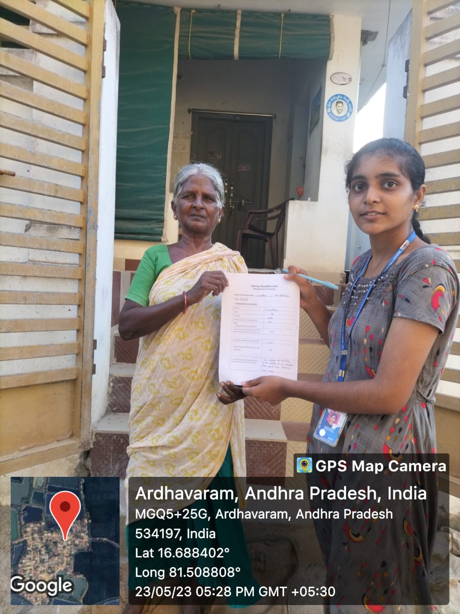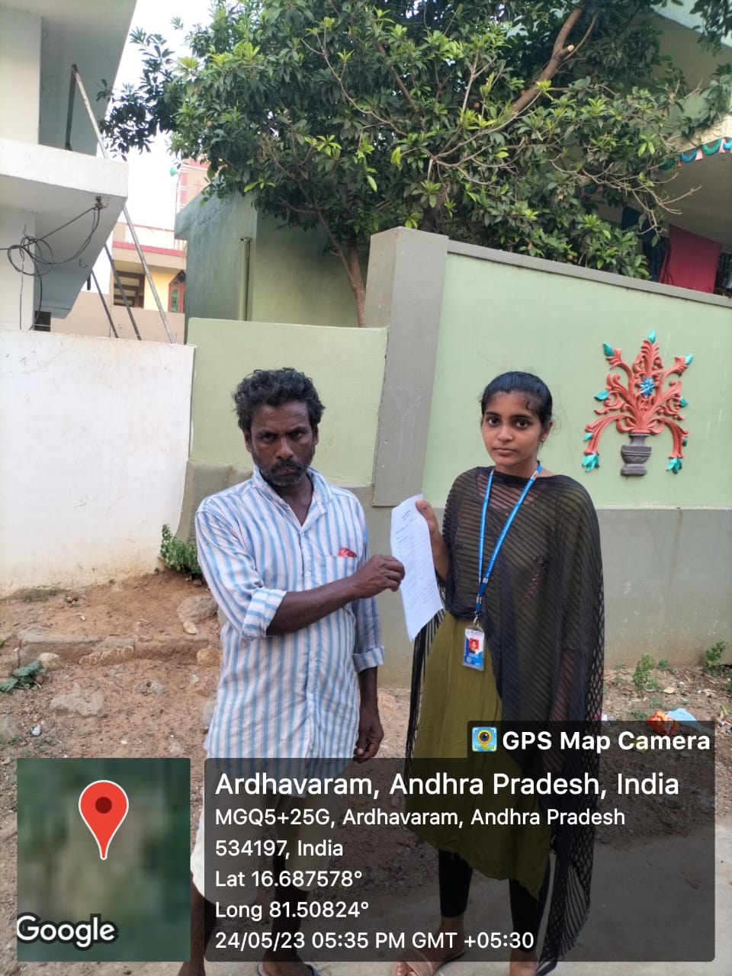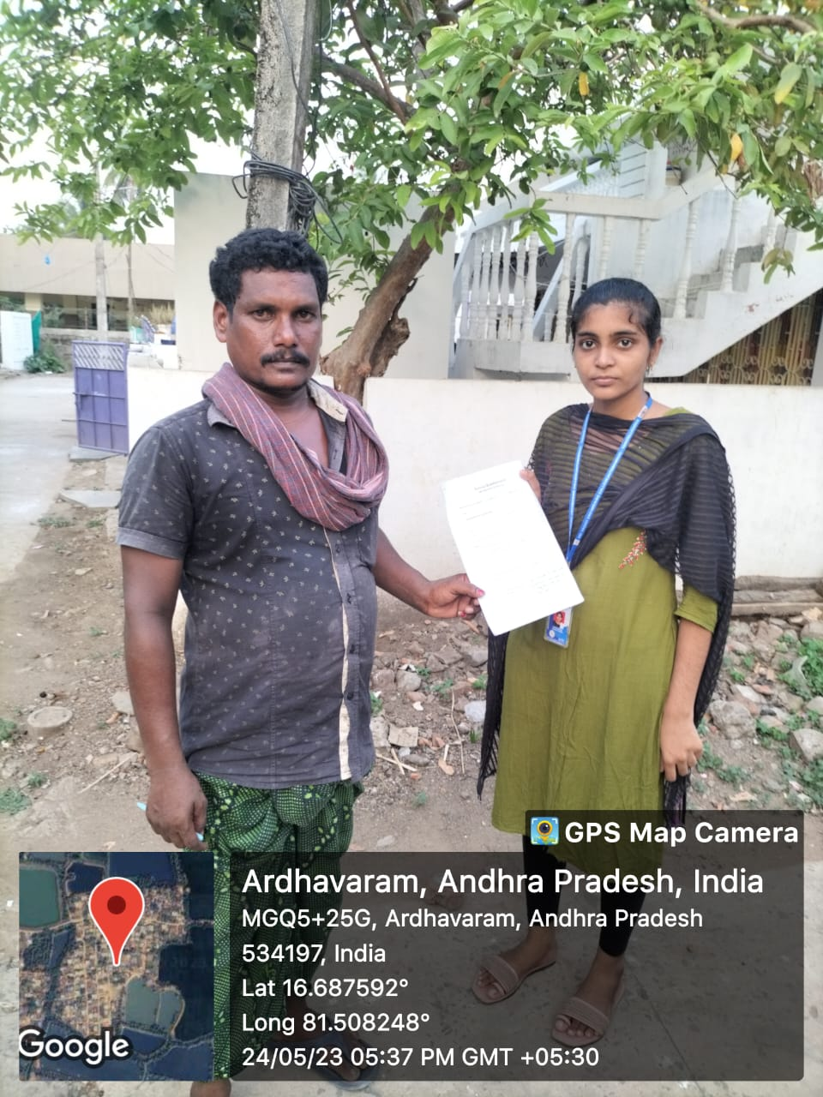*+67/8

# OBSERVATION

Social responsibility is like people and companies trying to do good things to make the world better. It's like when companies make sure they treat their workers fairly and don't harm the environment. People and communities also do good stuff like helping neighbors and volunteering.

People care a lot about nature now, like saving energy and not littering. Communities work together to make their neighborhoods nicer, with clean parks and safe streets. People also give money or time to help others who need it, like those who are sick or don't have enough food.

Companies see that people want to buy things from good companies, so they try to be responsible. Governments make rules to make sure companies treat everyone fairly and don't hurt the Earth.

But there are still problems, like not everyone getting treated the same way and some companies pretending to be good when they're not. So, while we see more people and companies trying to do good things, there's still work to do to make the world fairer and safer for every

# SUGGESTIONS

➢

# CONCLUSION

From our survey we came to understand that the school students should be aware of more outer knowledge. Schools should adapt teaching aspects that are taking place as part of 21st century evolution. Apart from education the students should enrich their skills by using the tech giant Google and most famous form of OTT i.e., YouTube. As everything is not been placed as a part of curriculum.

Encouragement in curricular activities as well as enriching sport activities should be increased. As they also play crucial role in shaping the student’s life by improving leadership skills and Team work abilities. The final foremost prior thing to be adapted is to take the student’s opinions to teach according to their heart.